# Web Application Setup Documentation in AWS :-

## Creation of a new instance in aws

Step 1)

Open aws management console <https://aws.amazon.com/console/>

Login with your user id & password .

[ayankr@rssoftware.co.in](mailto:ayankr@rssoftware.co.in) / admin123

Step 2)

Select Services -🡪 Compute --🡪EC2

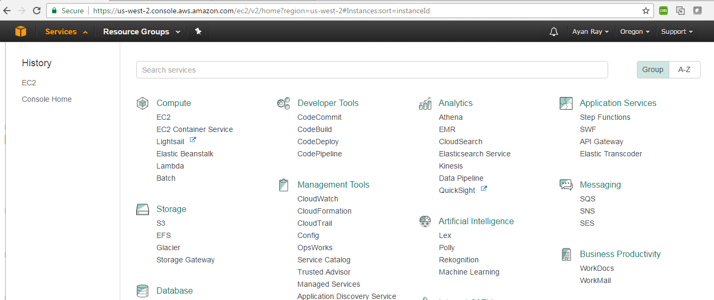

Step 3)

Select “launch instance”

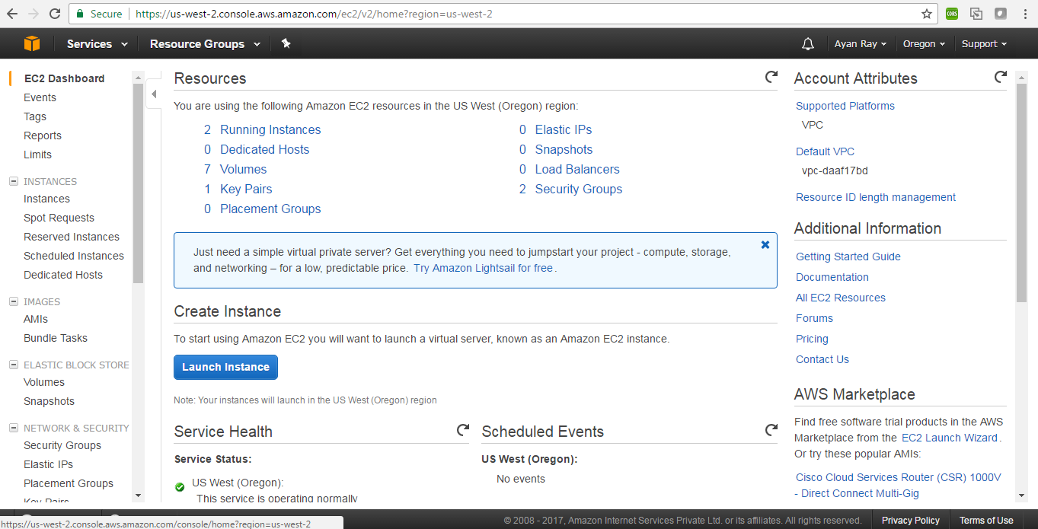

Step 4)

Select Amazon Linux AMI

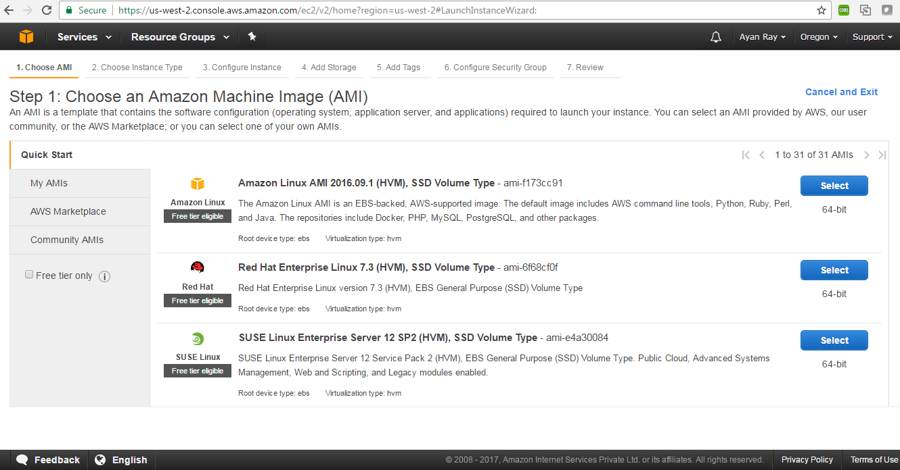

Step 5)

Select instance Type as same as below screenshot. (4 GB RAM)

Select “Next : Configure instance details”

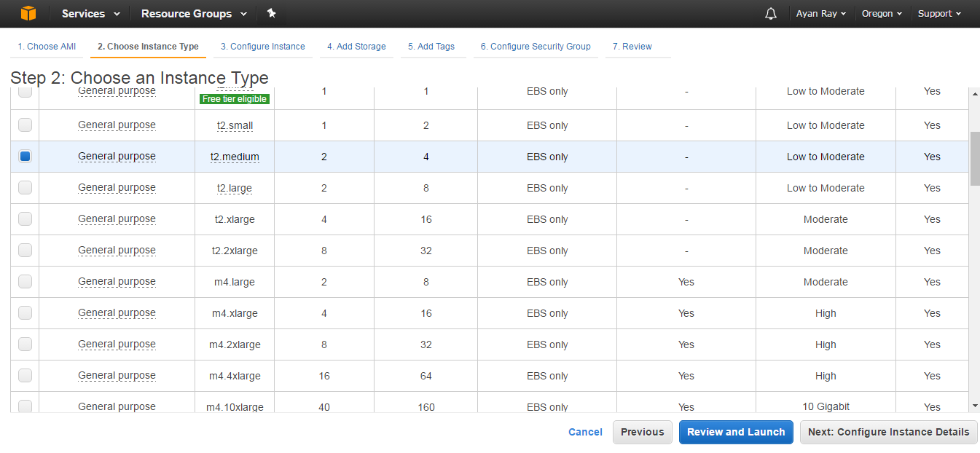

Step 6)

Do not change anything in this screen

Select “Next : Add Storage”

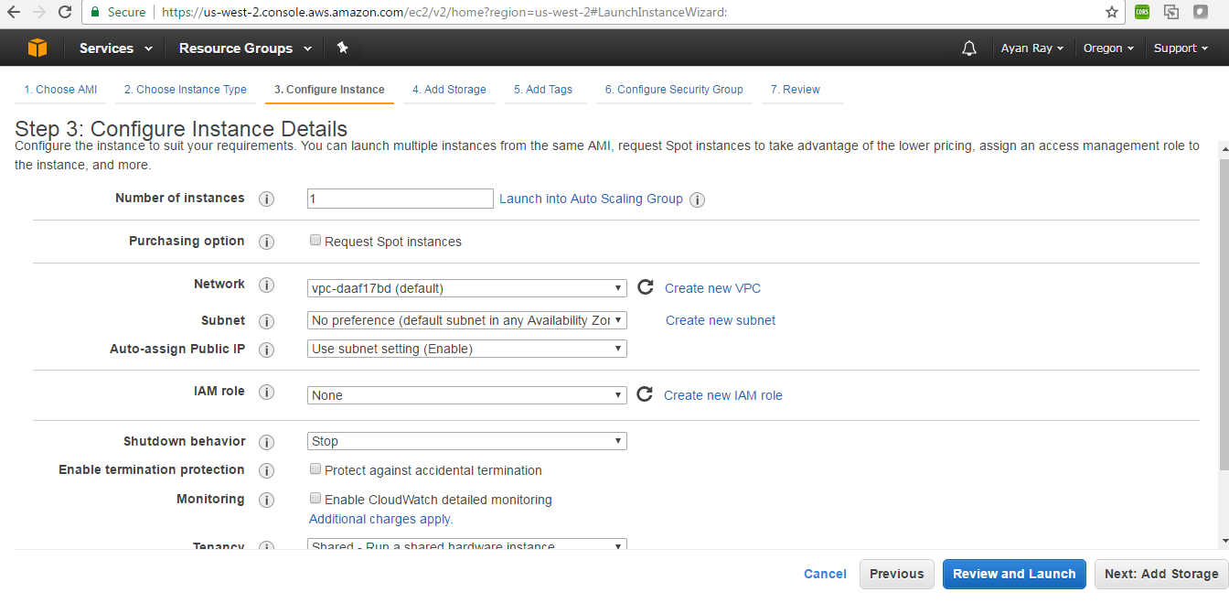

Step 7)

Put a storage size . I have made the storage 500 GB.

Select “Next: Add Tags”

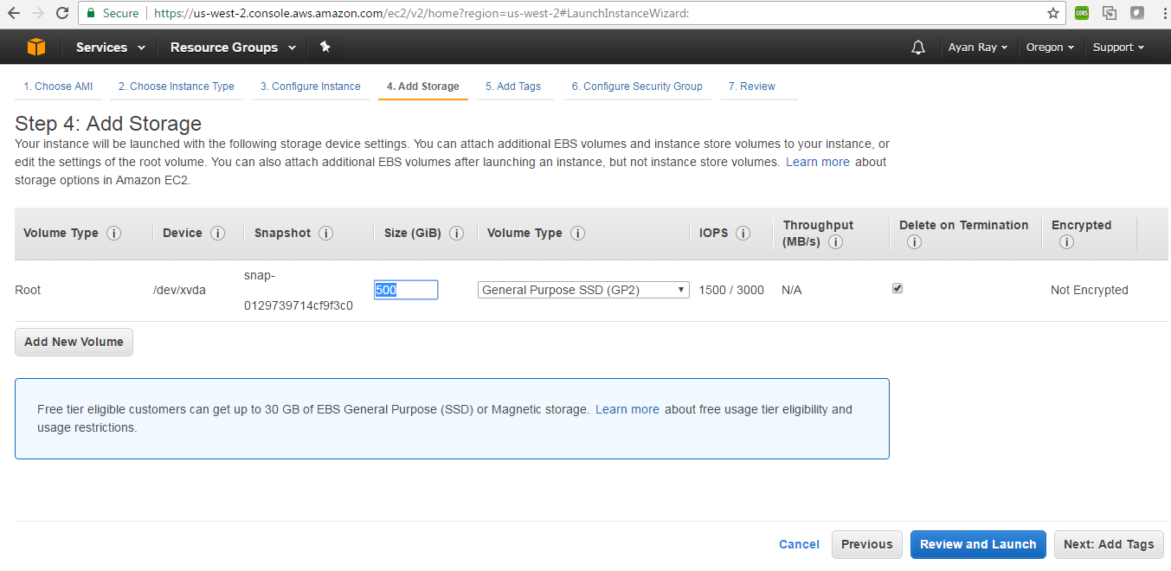

Step 8 )

Add a tag . I have made a tag like ER - Web-app

Select “Next:Configure security group”

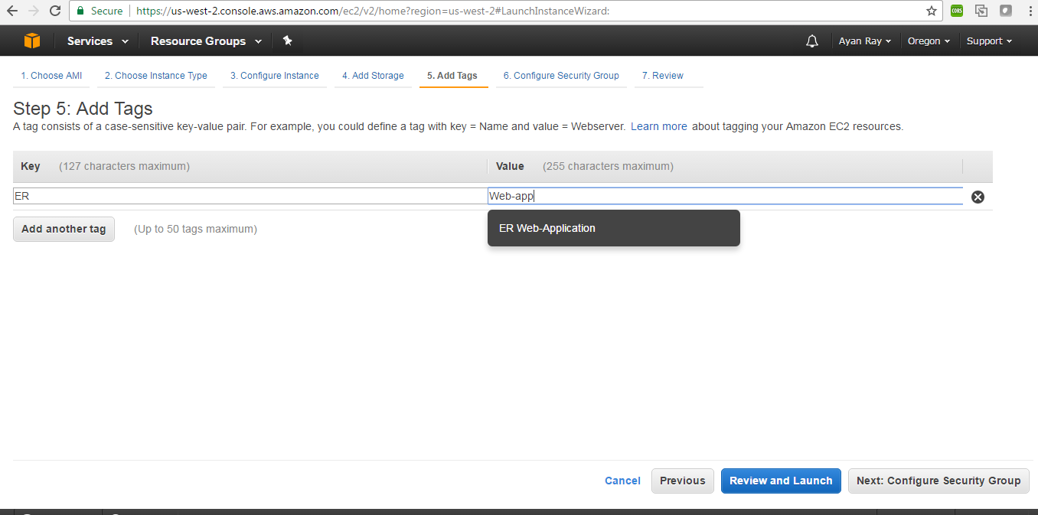

Step 9)

Select “Select an existing security group”

Select rssoftsecurity

Select “Review & Launch”

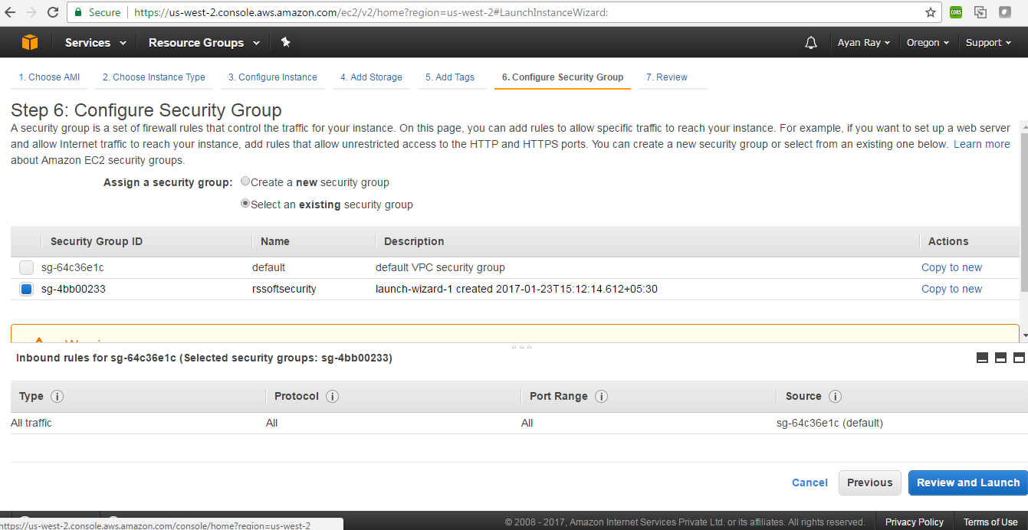

Step 10 )

Review well

Select “launch”

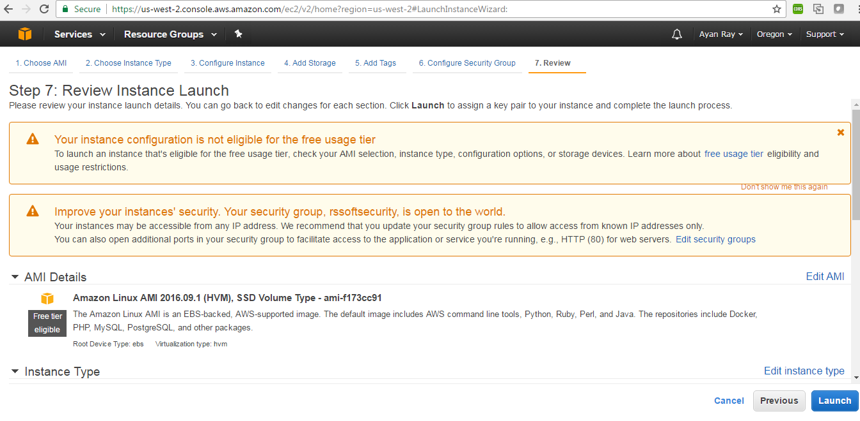

Step 11)

Select as same as below screenshot

Select launch instances

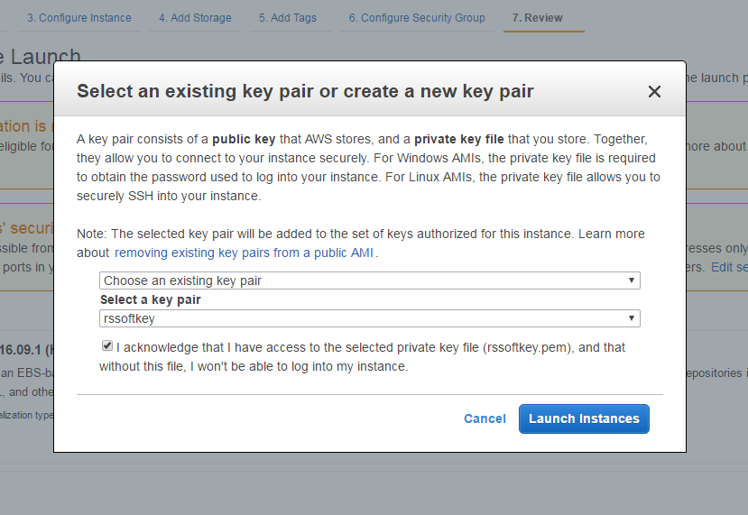

Instance is Ready to use .

Give a proper name , I gave it as – ER-Web-App

Check in console that instance is running or not.

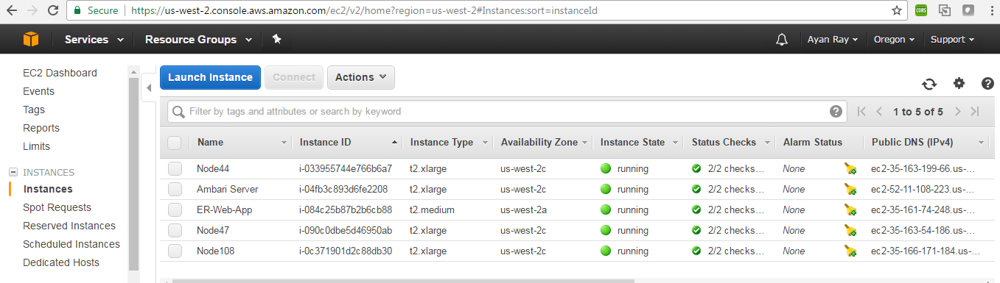

Step 12 )

Now , we will connect with putty .

1. Open putty
2. Select Connection -🡪 SSH 🡪Auth (from left side)
3. Browse the rssoftkey.ppk file



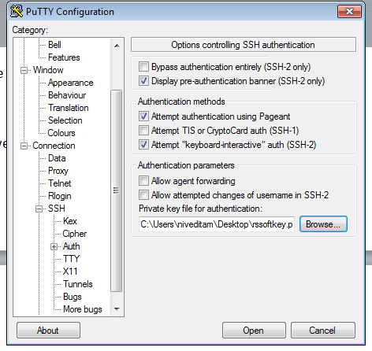

1. Select session
2. Copy the “Public DNS (IPv4)” for the particuler instance and paste it in the hostname
3. Use port 22
4. Select connection type - SSH
5. Save and open
6. Use login id –> ec2-user

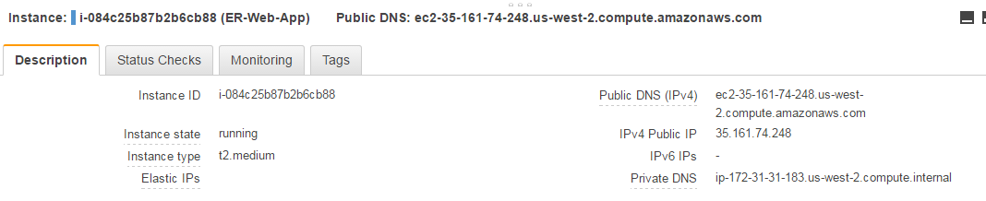

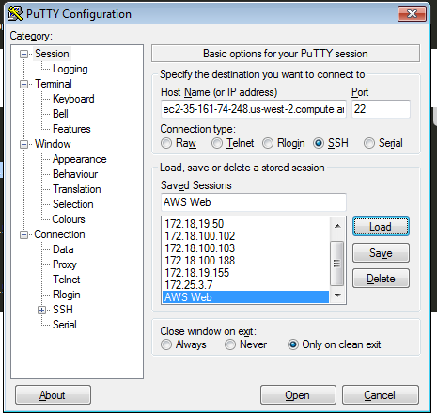

## Install Java Runtime

sudo yum install java-1.8.0

check the latest version of java is 1.8 or not –

[ec2-user@ip-172-31-31-183 ~]$ java -version

openjdk version "1.8.0_121"

OpenJDK Runtime Environment (build 1.8.0_121-b13)

OpenJDK 64-Bit Server VM (build 25.121-b13, mixed mode)

if any older version exists then remove with –

sudo yum remove java-1.7.0-openjdk

## MySQL Server set up

To install MySQL, ssh into your instance and type the following command:  
sudo yum install mysql-server

Check version:

[ec2-user@ip-172-31-31-183 ~]$ sudo mysql --version

mysql Ver 14.14 Distrib 5.5.54, for Linux (x86_64) using readline 5.1

To start MySQL:  
sudo service mysqld start

To stop MySQL:  
sudo service mysqld stop

## Mysql workbench connection

Open MySql workbench .

1. Select New Connection
2. Select the Standard TCP/IP over SSH from Connection Method.
3. Give SSH hostname – copy from public DNS



1. Give username – ec2-user
2. import the rssoftkey.pem file
3. Connect…

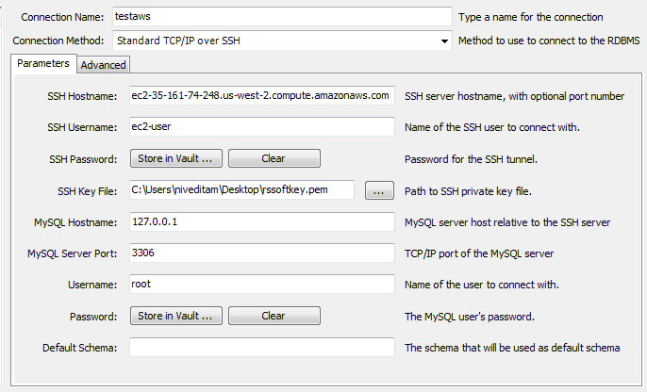

## Installation of Tomcat

To install tomcat, ssh into your instance and type the following command:  
sudo yum install tomcat8 tomcat8-webapps

To start Tomcat:  
sudo service tomcat8 start

To stop Tomcat:  
sudo service tomcat8 stop

You should now be able to access your Tomcat server from a browser using (use your own Public DNS address or Elastic IP):  
 <http://ec2-35-161-74-248.us-west-2.compute.amazonaws.com:8080/>

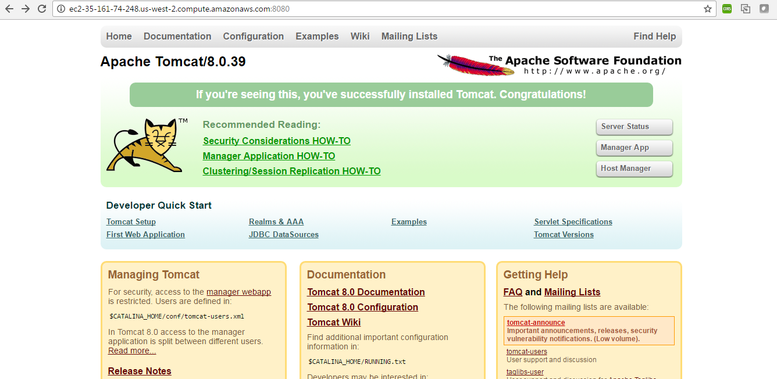

If not then do the following steps :

1. Go to Network & Security
2. Go to Security Groups
3. Select Create new Security Group

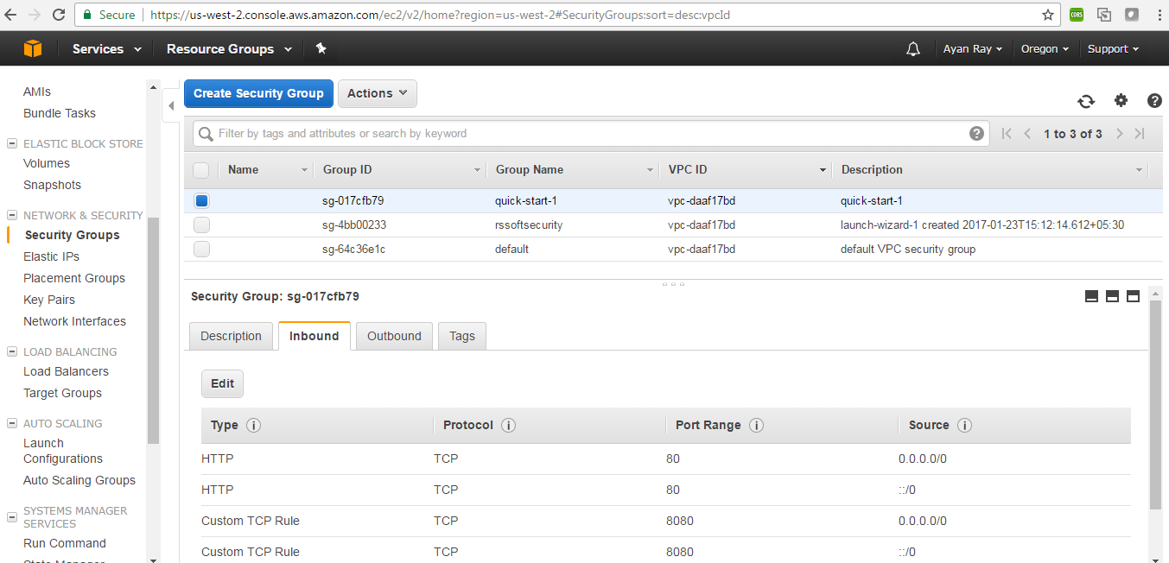

1. Do same as below screenshot
2. Select create

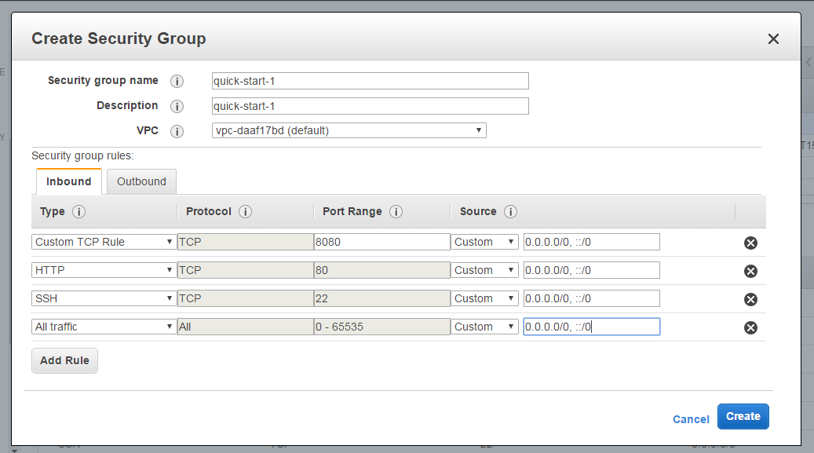

## Deploying the Application

1. Locate the tomat8/webapps

webapps:[ec2-user@ip-172-31-31-183 ~]$ whereis tomcat8

tomcat8: /usr/sbin/tomcat8 /etc/tomcat8 /usr/libexec/tomcat8 /usr/share/tomcat8

[ec2-user@ip-172-31-31-183 tomcat8]$ ls -ltr

total 4

lrwxrwxrwx 1 root tomcat 23 Jan 27 11:58 work -> /var/cache/tomcat8/work

lrwxrwxrwx 1 root tomcat 24 Jan 27 11:58 webapps -> /var/lib/tomcat8/webapps

1. Connect winscp and

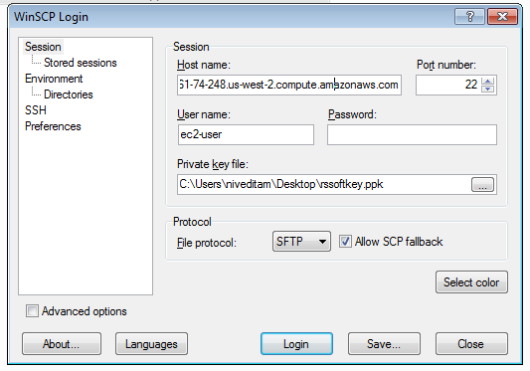

1. Copy the war file via Winscp to the /home/ec2-user directory
2. Move the war from /home/ec2-user to /var/lib/tomcat8/webapps

sudo cp /home/ec2-user/EntityResolution.war /var/lib/tomcat8/webapps

1. Start tomcat server

sudo service tomcat8 start

use this url from browser

http://ec2-35-161-74-248.us-west-2.compute.amazonaws.com:8080/EntityResolution/